Kevin Greene
88159017
Math 309
March 22nd 2004

Huygens’ Principle/Construct

Huygens, 1629-1695, greatly criticised Newton’s particle theory of light, and in 1678 developed his on idea on how light propagated. His method was highly geometric, and at the time had no mathematical basis.

Topics to be covered:
- Explanation of the techniques developed by Huygens
- Later modifications by others
- Potential flaw in construct
- How Huygens explained reflection and refraction
- How Huygens explained diffraction and interference

Huygens was dissatisfied with the current theories of light, either because they were too complicated, or they only worked in special cases. One of the topics that was not explained well according to Huygens, was diffraction. Up until then, there was no easy way to reproduce the how light could travel around a sharp edge.

Point Sources

Point sources are critical to Huygens’ Principle, so a brief overview is necessary.

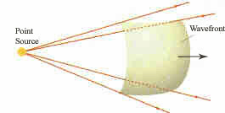

A point source emits light in all directions. The wavefront seen here is the locus of all points of a certain phase. That is, all points on this sphere are either all crests, or troughs, or somewhere between.

The radius of the sphere after a time t is r(t) = ct where c is the speed of light.

More importantly to Huygens, the radius after a time t + Δt is:

r(t + Δt) = c(t + Δt) = ct + cΔt

Where cΔt is the radius of what Huygens called wavelets. This new radius is the locus of points still in phase with each other.

In order to explain how light travelled, Huygens started with a wavefront.

Huygens then did something very strange. He broke up the wavefront that he had into a series of individual point sources. These sources will then in turn emit their own light.

Keeping with the notation from before, if a time Δt passes, then the radius of light from one of these point sources is cΔt. Here’s the second consideration that Huygens made: He only drew the part of the smaller sphere that’s in the direction the old wavefront was travelling in.

If you keep adding these wavelets to the point sources, you can see where the new wave fronts are in a line. This line represents all points of the same phase.

So if the original wavefront had travelled for a time t, and the wavelets for a time Δt, then the light has travelled a distance

r(t + Δt) = c(t + Δt) = ct + cΔt

Where again cΔt was the distance travelled by the wavelets.

These wavelets must travel at the same speed, and have the same frequency as the original wavefront, or else the wavelets won’t form a line of points in the phase after a time of Δt.

Huygens’ Principle/Construct

Each point on a primary wavefront serves as the source of spherical secondary wavelets that advance with a speed and frequency equal to those of the primary wave. The primary wavefront at some later time is the envelope of these wavelets.
-Paul A. Tipler

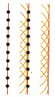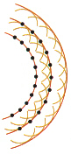

Modifications

After Huygens presented his theory, it was not generally accepted. This was mainly because the construct was geometric, and had not mathematical backing.

Fresnel was the first to truly back up Huygens, and he did so by showing that the new wavefront can be accuratly made by adding the wavelets of different amplitude and phases.

Fresnel also would use Huygens’ idea to explain and predict many diffraction patterns that would eventually be named after him. But Huygens’ wavelets were still not shown to be mathematically accurate.

Kirchhoff used Maxwell’s equations to show that the new wavefront is a result of the wave equation, finally putting Huygens’ Principle firmly in math. As well, Kirchhoff showed that the intensity of the wavelets backwards is zero in 1-D and 3-D.

Flaw in 2-Dimensions

A proof of what is to follow involves math beyond the scope of this course, and can be found at this site:

http://www.mathpages.com/home/kmath242/kmath242.htm

If the point sources were restricted to one dimension, there would be many cancellations in the wave equation, and the light would travel with the same intensity, continually building itself with each wavelet.

In 3-dimensions, the same cancellations occur. The wavefront in any direction from the original point source propagates as though it was in 1-dimension. This is because of the additive properties of the wavelets in 3-D, or the cancellation in the case of the waves going backwards.

In 2-D though, not enough cancellations occur. An observer would see the initial wavefront, but instead of disappearing, the light would gradually fade over an infinite time.

Any good theory of light must explain both reflection and refraction.

Reflection:
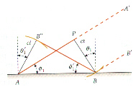
A wavefront AA’ travels a distance ct at an angle θ = φ. A point source at P has a wavelet at B. Similarly, the wavelet from A at a distance ct is at B”. The wavelets form a wavefront BB” moving at an angle θ’ = φ’. Since the two right triangles formed, APB and BB”A share a common edge AB, as well as a similar edge of length ct, the two triangle are congruent, and θ = φ = φ’ = θ’.

Refraction:
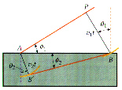

A wavefront AP is travelling at an angle θ₁ to the surface, and a wavelet from the point P to B has a radius of v₁t. Since the speed of light is slower in the second median, a wavelet from A travels at a slower speed v₂, and has a radius of v₂t. Connecting BB’ gives a wavefront travelling at an angle θ₂.

Now:
sin(φ₁) = v₁t / AB
or AB = v₁t / sin(φ₁)
And:
sin(φ₂) = v₂t / AB
or AB = v₂t / sin(φ₂)
So:
sin(φ₁) / v₁ = sin(φ₂) / v₂

Which is Snell’s law where v₁ = c / n₁ and v₂ = c / n₂

n₁ sin(φ₁) = n₂ sin(φ₂)

Diffraction and Interference

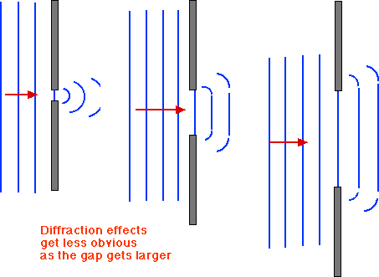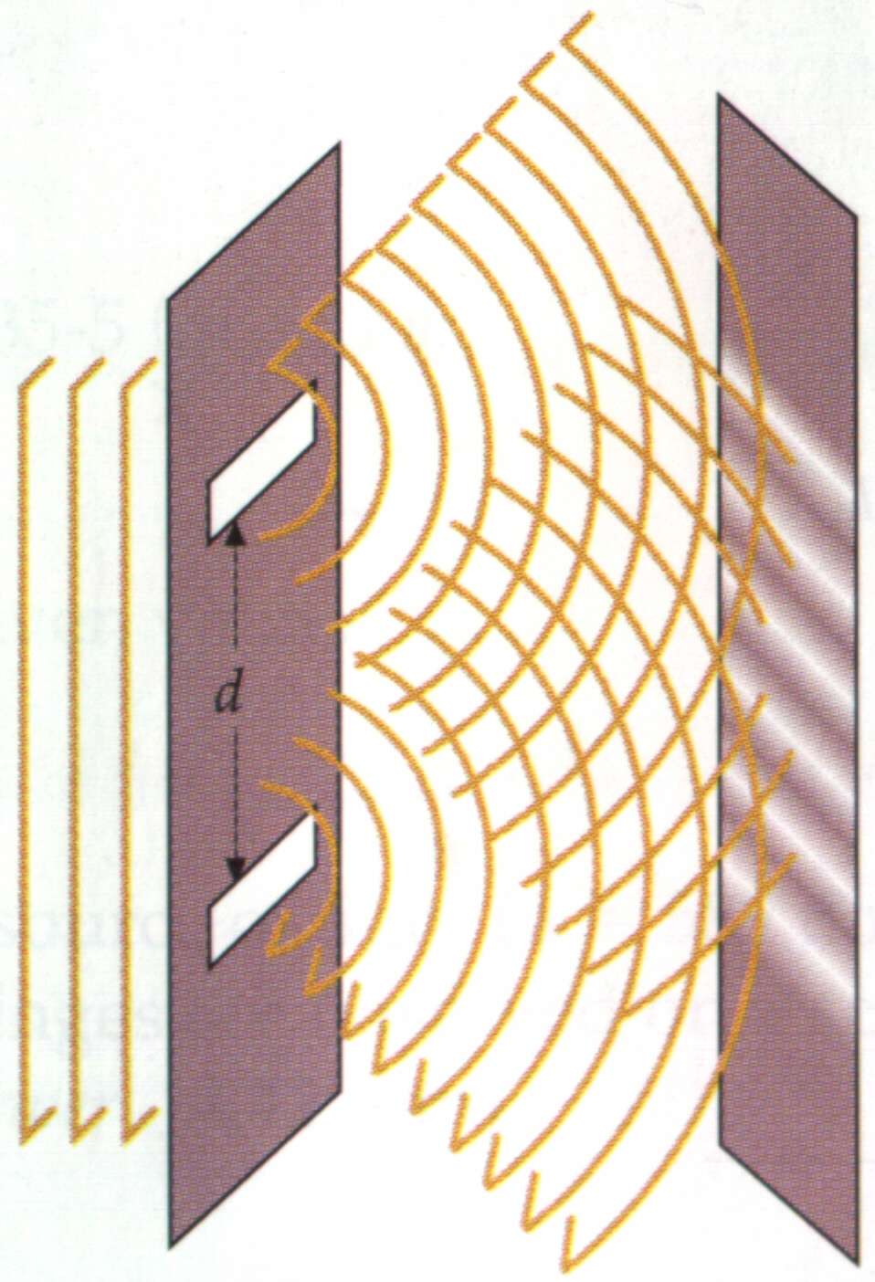

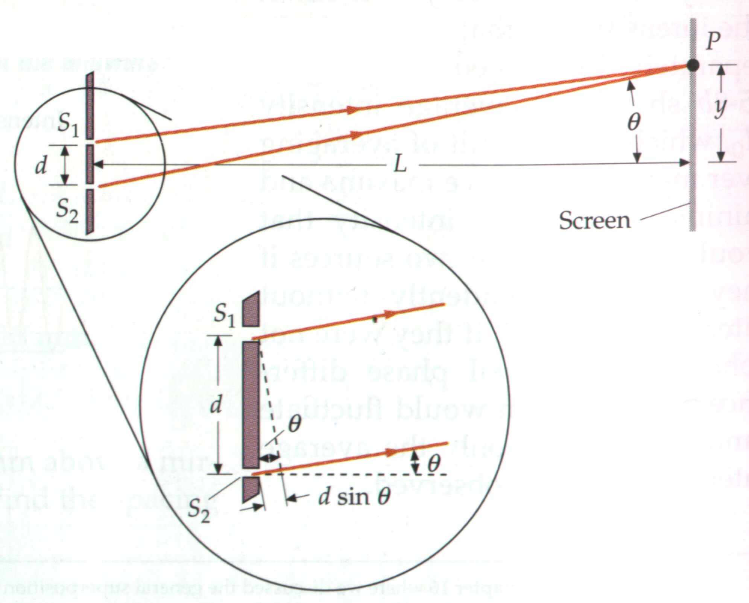

Related Sites and Sources

Biography:
http://www-gap.dcs.st-and.ac.uk/~history/Mathematicians/Huygens.html

Animations of Technique:
http://id.mind.net/~zona/mstm/physics/waves/propagation/huygens4.html
http://www.rit.edu/~visualiz/projects/huy.html (3-D animation)

Mathematical Proof:
http://www.mathpages.com/home/kmath242/kmath242.htm

Animations of Reflection and Refraction:

http://www.sciencejoywagon.com/physicszone/lesson/otherpub/wfendt/huygens.htm
http://www.phy.ntnu.edu.tw/java/propagation/propagation.html (recommended)

Diffraction:
http://www.launc.tased.edu.au/online/sciences/physics/diffrac.html

Quote and pictures:
“Physics; for Scientists and Engineers” 4th ed. Vol. 2. Tipler, Paul A.

