Basic Skills Test Analysis

1. The Basic Skills Test: A better predictor than high-school grades?

The following data were collected for students in MATH 180 and MATH 184 in 2007 and 2008:
- course final grades (hereafter referred to as CA grades)
- high-school grades (MATH 12 grades)
- grades from the BC Provincial Exam (PM 12 grades)
- scores on the Basic Skills Test (BST scores)

A correlation analysis was carried out to determine whether the Basic Skills Test is a good predictor of student success in first semester Calculus. Specifically, the Pearson correlation coefficient (r) was computed to obtain a measure of linear dependence between specific variables. Results are shown in Table 1.1, where N is the number of students in the sample, and BST grade is the BST best of 2 score.

Table 1.1
 |  | N | r | r²
MATH 180 | 2007
 | BST vs CA grades | 424 | 0.55 | 0.30
 | MATH 12 vs CA grades | 417 | 0.44 | 0.19
 | PM 12 vs CA grades | 293 | 0.42 | 0.18
 | 2008
 | BST vs CA grades | 446 | 0.60 | 0.36
 | MATH 12 vs CA grades | 417 | 0.54 | 0.29
 | PM 12 vs CA grades | 339 | 0.59 | 0.35
MATH 184 | 2007
 | BST vs CA grades | 500 | 0.60 | 0.36
 | MATH 12 vs CA grades | 485 | 0.43 | 0.18
 | PM 12 vs CA grades | 329 | 0.52 | 0.27
 | 2008
 | BST vs CA grades | 513 | 0.64 | 0.41
 | MATH 12 vs CA grades | 451 | 0.50 | 0.25
 | PM 12 vs CA grades | 344 | 0.53 | 0.29

Note that the correlation between BST scores and MATH 110 course grades was noticeable lower (r = 0.47, r² = 0.22) despite the wide range of BST scores earned by students in this course.

1.1 Discussion

Typically values of r range between –1 and +1: r = –1 for perfect negative correlation, r = +1 for perfect positive correlation, and r = 0 when there is no correlation. Any intermediate value is interpreted differently depending on context and purposes. In the social sciences, values of r are typically interpreted as
- |r| ≥ 0.5 for strong correlation
- 0.3 ≤ |r|< 0.5 for medium-strength correlation
- 0.1 ≤ r < 0.3 for weak correlation.

Based on these criteria, we find that all data sets show a good degree of (positive) correlation, with the strongest correlation being that between BST scores and final course grades consistently. Also, data from 2008 show a higher degree of correlation between BST scores and course grades than the previous year. This could suggest that the changes introduced in the 2008 set of BST’s resulted in more predictive information (despite being similar in content and layout, in 2008 some questions were substantially changed and the second test was created to be more closely comparable to the first test).

Values of r² are also reported in Table 1.1. When a linear relationship between two variables is modeled, values of r² are conventionally used as a measure of the percentage of the variance in the dependent variable that can be accounted for by changes in the independent variable. For example, in MATH 184 over the two years of data collection about 40% of the variance in the course grades can be accounted for by changes in the BST scores, which is another indication of a strong correlation between the two variables.

2. The Basic Skills Test: A Tool to predict students at risk?

The strong correlation of the BST scores with course grades suggests that the test could be used to predict student performance in the course and, in particular, to place students in the course most appropriate to their math level. To do so, we need to establish some criteria to identify the students that are at high risk of failing the course. Two methods were used, in both cases only 2008 data were used. First, a cut-off score in the BST is estimated after compiling the proportion of students who failed the course according to their BST scores. We also estimate a cut-off score by looking at overall values of the proportions of students that would be correctly and incorrectly predicted to pass or fail based on their BST scores.

2.1 Percentage of failures

We sorted students based on their BST (best of 2) score and, for each score group we computed the percentage of students who failed the course. Results from MATH 180 and MATH 184 are shown in Table 2.1 and Fig 2.1.

The distributions from the two courses appear quite similar, with perhaps a small difference in the low score range. In MATH 180 all students with a BST score of 12 or less failed the course, whereas only 80% of the students with such a score failed MATH 184. However, the sample size in the low score range is quite different in the two courses (15 students received 12 or less in the BST in MATH 184 and only 4 students had similar scores in MATH 180), so that difference may not be significant. It is clear, however, that at least in MATH 184, a score of 10 or less indicate level of mathematical skills inappropriate to the course.

Table 2.1 Percentage of failures.
 | MATH 180 |  |  | MATH 184
Score | N | Fail | %Fail | N | Fail | %Fail
<=10 | 2 | 2 | 100 | 10 | 10 | 100
<=11 | 2 | 2 | 100 | 11 | 10 | 90.91
12 | 2 | 2 | 100 | 4 | 2 | 50
13 | 4 | 3 | 75 | 3 | 2 | 66.67
14 | 4 | 2 | 50 | 9 | 5 | 55.56
15 | 8 | 5 | 62.5 | 9 | 5 | 55.56
16 | 8 | 4 | 50 | 23 | 11 | 47.83
17 | 15 | 7 | 46.7 | 26 | 11 | 42.31
18 | 22 | 11 | 50 | 26 | 10 | 38.46
19 | 23 | 7 | 30.4 | 32 | 8 | 25
20 | 31 | 5 | 16.1 | 52 | 12 | 23.08
21 | 38 | 12 | 31.6 | 48 | 7 | 14.58
22 | 42 | 8 | 19 | 56 | 9 | 16.07
23 | 44 | 6 | 13.6 | 43 | 4 | 9.302
24 | 44 | 4 | 9.09 | 49 | 7 | 14.29
25 | 32 | 0 | 0 | 32 | 4 | 12.5
>=26 | 102 | 4 | 3.92 | 88 | 1 | 1.136

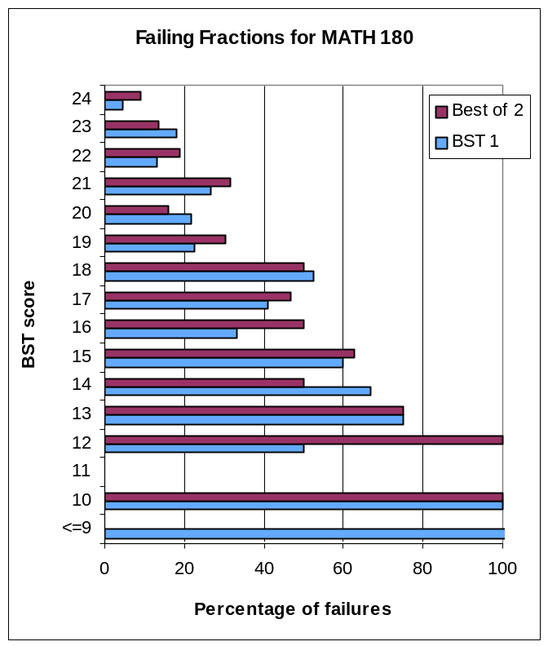Fig 2.1

One could select a cut-off score for the BST so that the probability of failing the course is in the 20%-30% range or below. Using these criteria, a least square fit to the distributions allows us to estimate the cut-off scores for each course. Values are shown in Table 2.2.

Table 2.2 BST (best of 2) cut-off score
MATH 180 MATH 184

30% prob. of failing the course 19 18
20% prob. of failing the course 21 20

2.2 Test Predictive Measures: Sensitivity and Specificity
To investigate at what level the BST can correctly predict whether a student will pass or fail the course, we made use of statistical measures common to the performance analysis of binary classification tests. Specifically, we computed the sensitivity and specificity of the BST using 2008 BST (best of 2) data.
When the goal of a diagnostic test is to identify students at risk for failing the course, the outcome of the test is ultimately a binary variable: positive when the test score is below a certain cut-off score, and negative when the test score is equal or above a certain cut-off score; a positive test result would, then, predict a failure in the course, while a negative test result would predict a pass. However, the actual performance of a student can be different from the prediction. In particular, four scenarios arise in which the outcome of the test is either
- true positive: a student who was predicted to fail does actually fail the course
- false positive: a student who was predicted to fail actually passes the course
- true negative: a student who was predicted to pass does actually pass the course
- false negative: a student who was predicted to pass actually fails the course
The sensitivity measures the proportion of actual positives (i.e., the proportion of students who do fail) that are correctly identified as such; the specificity measures the proportion of actual negatives (i.e. the proportion of students who do pass) that are correctly identified.

Number of true positives
Sensitivity =
Number of true positives + Number of false negatives

Number of true negatives
Specificity =
Number of true negatives + Number of false positives

Ideally, optimal prediction would achieve 100% sensitivity (i.e. predict all students in the class who are going to fail) and 100% specificity (i.e. not predict anyone who does pass the course as failing). In practice, for any test there is always a trade-off between these measures.

In addition to sensitivity and specificity, we also looked at the overall predictive value of the test, defined as
Number of True positives
Positive predictive value =
Number of all positives (true + false)

This is a measure of the proportion of students who were predicted to fail and did so.
Results are shown in Table 2.3.

Table 2.3: Test Predictive measures.
cut-off score | MATH 180 |  |  | MATH 184
cut-off score | sensitivity | specificity | predictive value | sensitivity | specificity | predictive value
12 | 0.02 | 1.00 | 1.00 | 0.09 | 1.00 | 0.91
13 | 0.02 | 1.00 | 1.00 | 0.11 | 0.99 | 0.80
14 | 0.05 | 1.00 | 1.00 | 0.13 | 0.99 | 0.78
15 | 0.09 | 1.00 | 0.88 | 0.18 | 0.98 | 0.70
16 | 0.11 | 0.99 | 0.75 | 0.22 | 0.97 | 0.67
17 | 0.17 | 0.98 | 0.70 | 0.32 | 0.94 | 0.59
18 | 0.22 | 0.97 | 0.64 | 0.43 | 0.90 | 0.54
19 | 0.30 | 0.95 | 0.58 | 0.52 | 0.86 | 0.50
20 | 0.44 | 0.91 | 0.55 | 0.59 | 0.80 | 0.45
21 | 0.52 | 0.87 | 0.49 | 0.70 | 0.70 | 0.39
22 | 0.59 | 0.79 | 0.40 | 0.77 | 0.60 | 0.34
23 | 0.73 | 0.71 | 0.38 | 0.85 | 0.49 | 0.31
24 | 0.83 | 0.61 | 0.34 | 0.89 | 0.39 | 0.28
25 | 0.90 | 0.50 | 0.30 | 0.95 | 0.29 | 0.26

Values of sensitivity and specificity can be used to select a BST cut-off score that would identify the largest percentage of students at risk of failing (sensitivity) and distinguish them from students who would instead be success in the course (specificity). A reasonable cut-off score could be the score yielding about 90% correct prediction in the passing category (ie. no more than 10% of those predicted to pass actually failed) and the highest corresponding sensitivity. Thus, we estimate a cut-off score of 21 for MATH 180 and 19 for MATH 184. For both courses, this would correspond to predicting about 86% of students in the passing category and 52% in the failing category. At these cut-points, however, the overall predictive value of the test is only about 50% in both courses.

3. Improvements on BST 2

Students who scored less than 20 in the first test (BST 1) were required to write the second test (BST 2) two weeks later. Did they improve their scores? To answer this question, we plotted scores on the second test vs the score earned in the first test, as shown in Fig. 3.1 and 3.2. The straight line indicates no change between tests.

In MATH 180 about 48% of the students who earned less than 20 on BST 1 improved their score on BST2, similarly 59% of students in MATH 184. However, all MATH 180 students who scored 10 or less on BST 1 improved, while only one MATH 184 students who scored 14 on BST 1 improved on BST 2.

The average improvement was about 3.5 points (it was slightly higher in MATH 180 due to one student who improved by 11 points on BST2).

While for MATH 184 there is no significant change between the correlation coefficient calculated between BST 1 scores and course grades and that calculated between BST best of 2 score and course grades ( r(BST 1) = 0.63, r(BST best of 2) = 0.64), for MATH 180 it appears that the BST best of 2 score is a better predictor of course grades ( r(BST 1) = 0.46, r(BST best of 2) = 0.60).

Fig. 3.1 Fig. 3.2


