MATH 152 Computer Labs

End of Term Survey

N = 263 ( 37.5% of enrolled, enrolled N = 700)

1A. How would you describe the lab assignments? Pick as many options as you like.

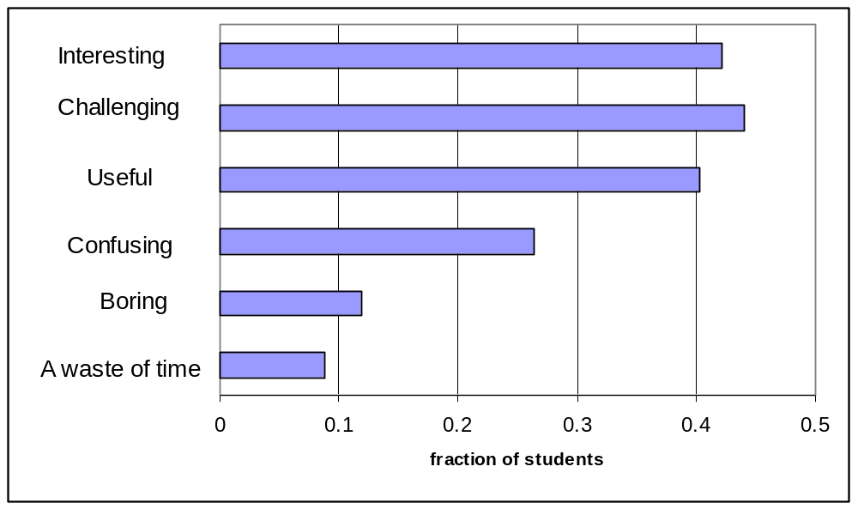

2A. How often do you read the lab assignments before the beginning of the lab?

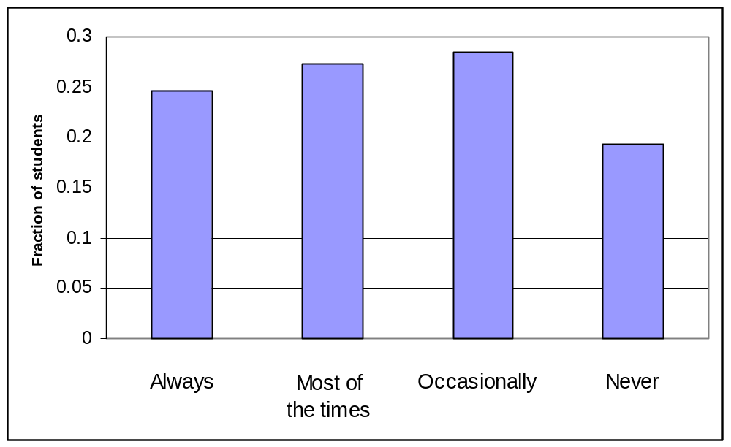

3B. What is the purpose of an m file in MATLAB?

15% (N = 39) blank/nonsensical

Please rate the extent you agree or disagree with each of the following statements by marking the appropriate letter.

1. The computer labs are related to the material covered in class.
2. The exercises done in the labs help me understand concepts covered in class.
3. The exercises done in the labs provide useful practice for solving problems on tests.
4. The lab assignments show interesting linear algebra applications.
5. MATLAB is a useful tool to solve linear algebra problems.
6. Programming in MATLAB is challenging.
7. I will likely use MATLAB to do computations in the future, even if not prompted to.
8. The lab handouts are clear and easy to follow.
9. I am often confused about the goal(s) of the labs.
10. The TA provides useful help when I am stuck.

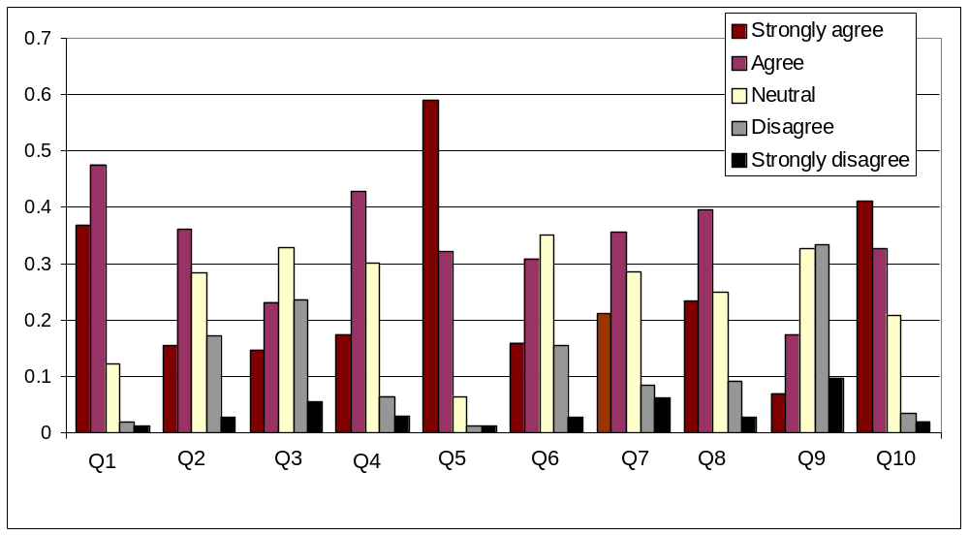

11. What aspect of MATH 152 would you most like to see improved? Pick only ONE option.

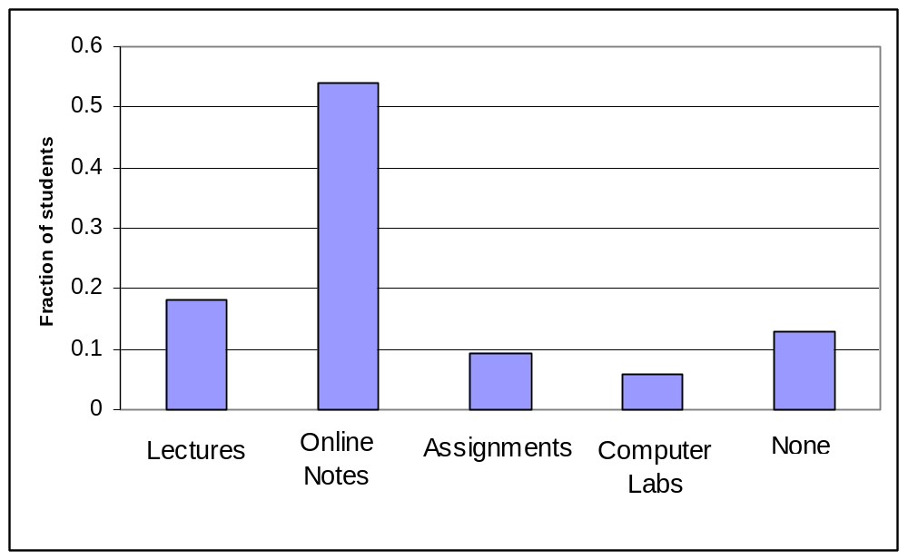

How would you improve it?

Online Notes: more concrete examples, break notes down into more sections, add learning goals to sections
Labs: more time, shorten labs
Assignments: more related to lecture material, use Matlab in assignments

12. What is the one thing you find most valuable about the computer labs?

Learn Matlab (N=35)
See linear algebra applications/or apply concepts from lectures (N = 18)
Solve problems fast (N = 10)
Reinforce concepts from lectures (N = 15)
Useful to check answers to assignments (N=8)
Working with technology/computers (N=6)
Get practice/experience (N=10)
Makes hard calculation easy (N=15)
See how a software package can be used in math (N=3)
Programming (N=5)
TAs (N=4)
Easy marks (N=4)
Open lab time (N=4)

13. What suggestions, if any, do you have for making the labs more useful for your learning?
(If you have more than one suggestion, please, list them in order of importance)

more time to finish labs (N=17) (suggested lab time: 1.5hr)
shorten labs (N=7)
online submission, discuss/present labs in lectures, weekly labs, tutorial session during off-week,
change computers, add more real-life applications, give overview of lab at the beginning of lab

