Calculus Workshops End of Term Survey

The end of term survey had two sets of questions.

Set I: Students were asked to express to what extent they agree or disagree with the following statements:

Q1. The workshop problems provide useful practice for solving problems on tests.
Q2. The workshop problems are related to the material covered in class.
Q3. The workshops are a waste of time.
Q4. The workshop problems are too challenging.
Q5. The workshop problems are interesting.
Q6. I am often confused about the goal(s) of the workshops.
Q7. I like working with my group members.
Q8. The anxiety of writing a quiz at the end of a workshop prevented me from learning.
Q9. I would recommend having similar workshops in this course again next year.

Set II: Students were asked to rate the frequency with which the following actions occur during the workshops:

Q10. Read the problem statement repeatedly before starting any calculation.
Q11. Draw a picture to visualize the situation described in the problem.
Q12. Restate what you need to find by naming specific mathematical variables.
Q13. Write down what you know about the problem using a mathematical notation.
Q14. Outline how you will solve the problem before doing any calculation.
Q15. Try to figure out how to check whether your solution makes sense.

Math 184 No. of surveys = 388, 75% of registered students (Total enrolment = 519)

Results (all sections)
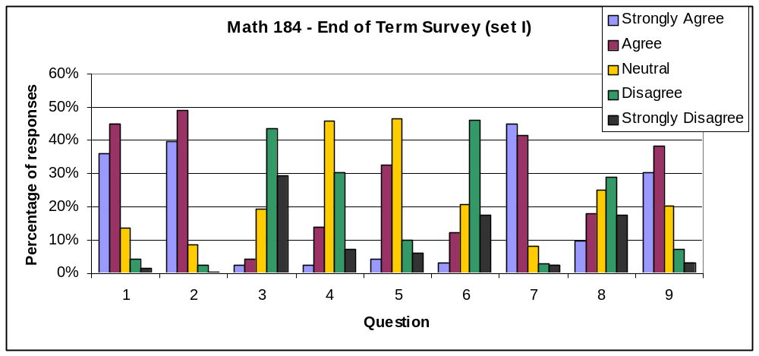
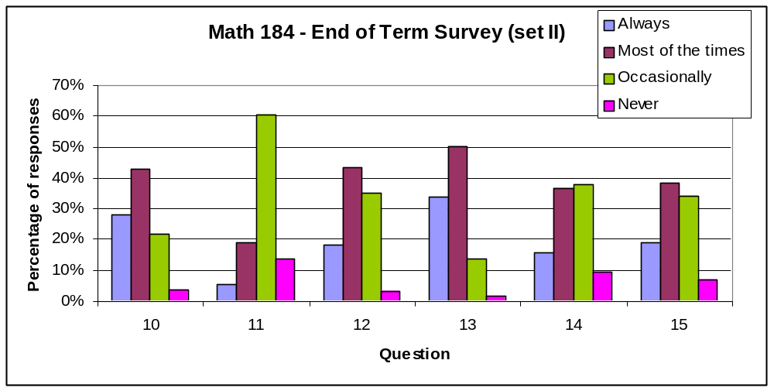

Comparison with last year workshops

Q1 through Q6 from Set I were included in an end-of-term survey last year. Results from last year’s survey are shown below. A significant difference in responses can be found in most of the questions. From Q1 and Q3 we see that this year students found the workshops more useful and more related to what they do in class than last year. Students are also less confused about the goals of the workshops (Q6). It is interesting to notice that this year students did not find the workshop problems as challenging as they did last year (Q4). This can be explained by the change in pre-requisites for this course. This year the weaker students were moved to a different course. However, a large fraction of the workshop problems also changed from last year, and even though we had no intention to lower their difficulty level, it is often difficult to gauge student difficulties correctly.

Q.1.1 | 2008/09 | 2009/10 |  | Q.1.2 | 2008/09 | 2009/10
Strongly Agree | 17% | 36% |  | Strongly Agree | 17% | 40%
Agree | 42% | 45% |  | Agree | 44% | 49%
Neutral | 25% | 13% |  | Neutral | 27% | 9%
Disagree | 10% | 4% |  | Disagree | 9% | 2%
Strongly Disagree | 5% | 1% |  | Strongly Disagree | 2% | 1%
Q.1.3 | 2008/09 | 2009/10 |  | Q.1.4 | 2008/09 | 2009/10
Strongly Agree | 5% | 3% |  | Strongly Agree | 3% | 2%
Agree | 12% | 4% |  | Agree | 25% | 14%
Neutral | 22% | 19% |  | Neutral | 45% | 46%
Disagree | 40% | 43% |  | Disagree | 25% | 30%
Strongly Disagree | 20% | 29% |  | Strongly Disagree | 2% | 7%
Q.1.5 | 2008/09 | 2009/10 |  | Q.1.6 | 2008/09 | 2009/10
Strongly Agree | 5% | 4% |  | Strongly Agree | 7% | 3%
Agree | 32% | 33% |  | Agree | 14% | 12%
Neutral | 42% | 47% |  | Neutral | 34% | 21%
Disagree | 17% | 10% |  | Disagree | 35% | 46%
Strongly Disagree | 4% | 6% |  | Strongly Disagree | 10% | 18%

All questions in Set II were also included in last year’s end of term survey. Results are below. The largest difference in responses can be found in Q11, where students were asked how often they visualize a problem with a picture. I don’t know how to interpret this result, except that some of the economics problems that were introduced in the workshops to replace other more geometrical problems may have made any attempt to visualize the problem too hard. Some of the worksheets used in the workshops this year included most of the steps described in these questions, however I don’t think the instructions given to students by TAs had changed from last year, so it remains unclear how to interpret some of the changes in responses.

Q.10 | 2008/09 | 2009/10 |  | Q.11 | 2008/09 | 2009/10
Always | 29% | 28% |  | Always | 9% | 5%
Most of the times | 34% | 43% |  | Most of the times | 43% | 19%
Occasionally | 31% | 22% |  | Occasionally | 44% | 61%
Never | 5% | 4% |  | Never | 4% | 14%
Q.12 | 2008/09 | 2009/10 |  | Q.13 | 2008/09 | 2009/10
Always | 16% | 18% |  | Always | 22% | 34%
Most of the times | 42% | 43% |  | Most of the times | 47% | 50%
Occasionally | 37% | 35% |  | Occasionally | 28% | 14%
Never | 4% | 3% |  | Never | 3% | 2%
Q.14 | 2008/09 | 2009/10 |  | Q.15 | 2008/09 | 2009/10
Always | 9% | 16% |  | Always | 9% | 19%
Most of the times | 24% | 37% |  | Most of the times | 31% | 38%
Occasionally | 52% | 38% |  | Occasionally | 45% | 34%
Never | 16% | 9% |  | Never | 15% | 7%

Are the weekly quizzes a problem for the students?

The end of term survey included the open-ended question: “What is the one thing you find the least valuable about the workshops?”

On average, about 20% of the students reported that the weekly quizzes were the least valuable thing of the workshops. When analysed based on the day of the week students attend the workshops, these data show no correlation.

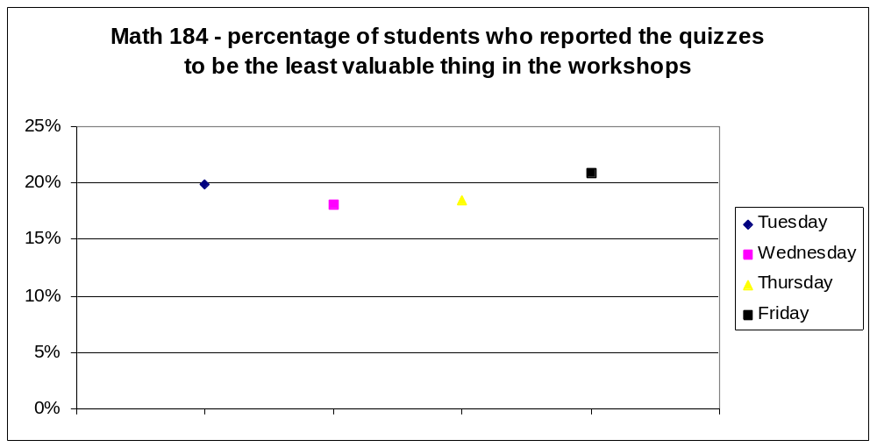

A similar analysis based on the day of the week was made on the responses to Q8 (set I). Overall, 28% of the students admitted to feeling anxious for the quiz and that that anxiety effected their learning. It would seem that the level of anxiety decreases later in the week, however the sections with workshops on Wednesday have a particularly small percentage of anxious students.

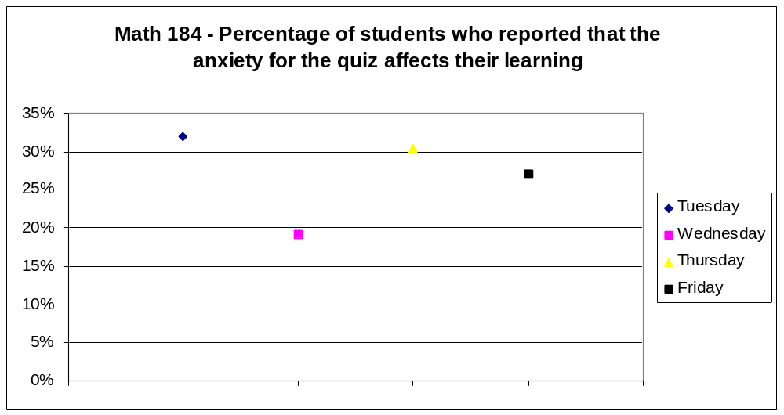

The decrease of anxiety in later workshops may be explained by a longer exposure to the workshop material in lectures and homework, and perhaps the intervention of the TAs (??).

MATH 180 No. of surveys = 350, 80% of registered students (Total enrolment = 438)

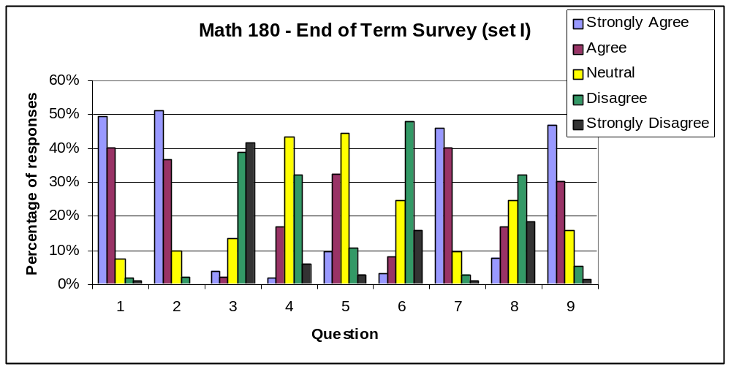

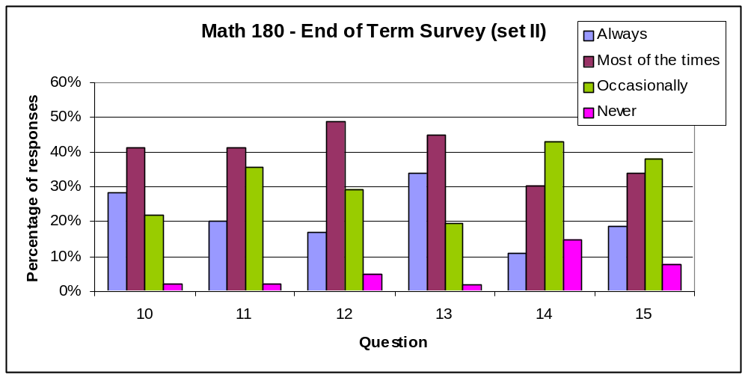

Last year there was no end-of-term survey in Math 180, so no comparison is possible here.

As for the effect of the quizzes, about 25% of the students admitted to feeling anxious for the quiz, with less anxious students in workshops on Thursdays and Fridays.

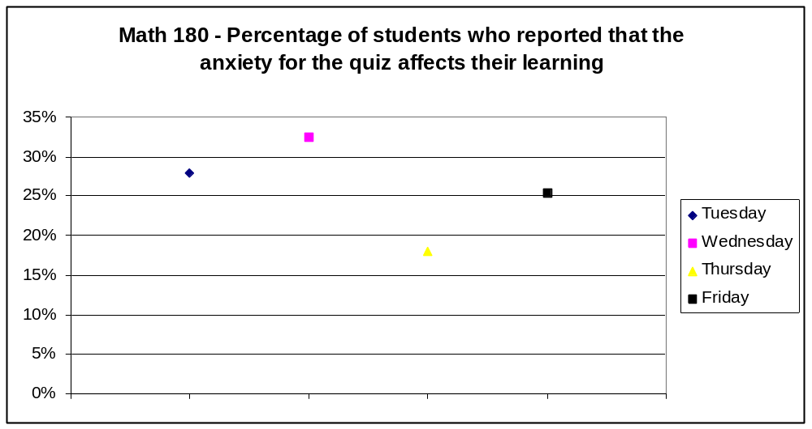

Similarly to Math 184, the end of term survey included the open-ended question: “What is the one thing you find least valuable about the workshops?” As in Math 184, about 20% reported the quizzes as the least valuable thing, with no correlation with the day of the week they attend workshops.



