MATH 256 (Mech 221) - 2009

- Student performance on exam questions

I analysed students’ performance on the Math questions of the December 2009 exam. The exam contained three Math questions: two short questions [5 marks each], one including Matlab (Q1) and one including only analytical computations (Q2), and a long-answer question (Problem 1) [25 marks] with no Matlab. The three questions tested different math concepts. Average scores on these questions are all similar, suggesting similar degrees of mastery of analytical and numerical tasks.

Exam question Mean Scores (out of 100) +- st. dev

Q1(a) [interpreting the output of a “for” loop] 77.6 +- 33.9
Q1(b) [identifying and correcting errors in the code] 74.8 +- 35.6
Q1 (a) +(b) 76.5 +- 29.3
Q2 [analytical question, no Matlab] 71.3 +- 16.4
Problem 1 75.9 +- 26.3

The correlation between scores on the Matlab question and the other two questions is small, and so is the correlation with final computer lab scores:

Correlation coeff. between Q1 scores and Q2 scores r = 0.26
Correlation coeff. between Q1 scores and Problem 1 scores r = 0.23
Correlation coeff. Between Q1 scores and Labs scores r = 0.15

2. Typical student errors

Q1 in the Mech 221 December 2009 exam:

Your friend Bob is trying to write MATLAB code that will find an approximate solution of the scalar initial value problem
dy/dt = cos(y + t) with y(0)=1
Bob wants his code to approximate y(0.3) using 3 Forward Euler steps of size h = 0.1 The code runs but does not generate the right answer that Bob worked out using his calculator.

h =0.1;
t=0;
y=1;
for i=1:3
y = y + cos(y+t)
end

(a) [3 marks] Step through the code and write down the three numbers that will be printed out.
(b) [2 marks] There are two errors in the code. Find and correct these errors so that the code will produce the correct result.

Some statistics on this question:

# of students writing the test N = 119
# of students who scored full marks on Q1 N = 4, 3%
# of students who scored less than full marks in part (a) N = 38, 32%
# of students who scored less than full marks in part (b) N = 45, 38%
# of students who scored 0 on part (a) N = 6, 5%
# of students who scored 0 on part (b) N = 15, 13%

Average score (out of 100): (a) 77.6% , (b) 74.8%, overall (a+b) 71.2%

Typical errors:

Part (a): did not update the value of the first y in the expression y+cos(y+t), so they y=1 each time
Part (b): 16% of students (N=19) did not recognize the error involving the step size h
9% of students (N = 11) did not recognize the error involving t
13% of students (N= 16) corrected the code by making y a vector

3. Lab day effect

Last term it was reported that the section attending the computer labs on Mondays had often difficulties in completing the labs in the allotted time, while students in other sections were observed to be working through the lab tasks with the help of other students’ solutions. It was speculated that this behaviour would affect learning, so I looked at student performance in the Mech 221 December exam (section-averaged overall score on all Math questions and section-averaged score on the single Matlab question), and compared it with performance in the Computer Labs, the Mech 220 Software module given in September, and the Mech 220 Entry quiz (score on marked questions, not including Matlab). Results are below.

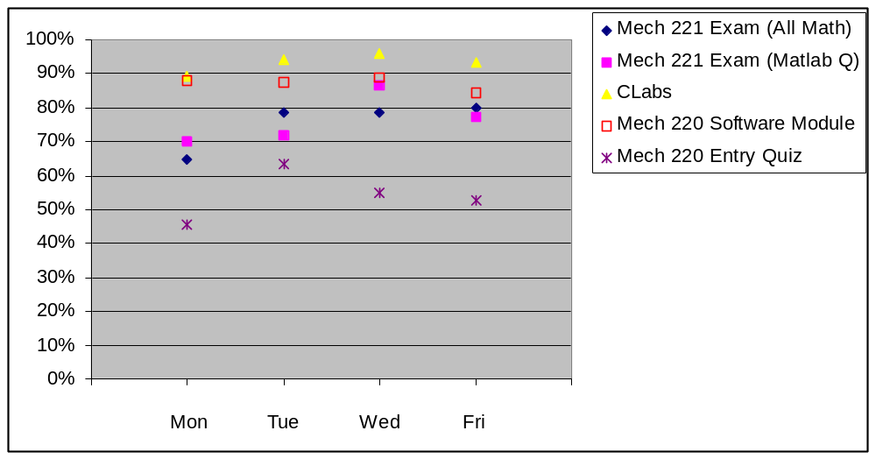

Discussion:

The Monday section performed significantly worse in the Mech 221 final exam (Math portion) then the other sections, however it also started with a weaker Math & Physics background knowledge as shown by the Entry quiz, which tests 1st year math & physics knowledge. So we cannot conclude that attending the labs on Monday (when supposedly students may have focused more on operational rather conceptual tasks in the labs) affected their overall learning of math. However, if we look at how students performed on the single Matlab question in the Mech 221 final exam and use the Mech 220 Software module scores as a baseline, then it appears that the Wednesday and Friday sections displayed higher levels of mastery of Matlab. The Wednesday section is reserved for Mechatronics students – a special option in Mech for students with an interest in mechanical engineering, electrical engineering, and computer science. This may explain the considerably higher marks on the software question. The Friday section is more interesting: they performed slightly worse than anybody else in the Mech 220 software module, but did better than the early week sections in the Mech 221 Matlab question, however the differences in the Mech 221 scores across the Mon and Fri sections are not statistically significant. In conclusion, I don’t think these data show any effect on learning due to the day of week when students attended the labs.

